Ex.No: 2 Roll.No: 210701182

# PYTHON PROGRAM TO BUILD A CONVOLUTIONAL NEURAL NETWORK WITH KERAS

Aim:

To build a convolutional neural network with Keras in Python.

# Procedure:

1. Import TensorFlow and Keras modules for building and training the model.
2. Load the CIFAR-10 dataset consisting of 60,000 32x32 color images across 10 classes.
3. Normalize the pixel values of the training and testing images to be between 0 and 1.
4. Print the shape of the training and test images and labels to verify the dataset dimensions.
5. Create a Sequential CNN model starting with a 32-ﬁlter Conv2D layer followed by MaxPooling.
6. Add two more Conv2D layers with 64 ﬁlters each, followed by MaxPooling and activation.
7. Flatten the feature map and add a Dense layer with 64 units and an output layer with 10 units.
8. Compile the model using Adam optimizer, Sparse Categorical Crossentropy loss, and accuracy metrics.
9. Train the model for 10 epochs with validation on test data and store the training history.
10. Evaluate the model’s accuracy on the test set and visualize the accuracy and loss during training using plots.

# Code:

import tensorﬂow as tf

from tensorﬂow.keras import layers, models import matplotlib.pyplot as plt

# Load the CIFAR-10 dataset

(train_images, train_labels), (test_images, test_labels) = tf.keras.datasets.cifar10.load_data()

# Normalize pixel values to be between 0 and 1

train_images, test_images = train_images / 255.0, test_images / 255.0

# Print the shape of the dataset

print(f"Training images shape: {train_images.shape}") print(f"Training labels shape: {train_labels.shape}") print(f"Test images shape: {test_images.shape}") print(f"Test labels shape: {test_labels.shape}")

model = models.Sequential([ # Convolutional layer 1

layers.Conv2D(32, (3, 3), activation='relu', input_shape=(32, 32, 3)),

layers.MaxPooling2D((2, 2)),

# Convolutional layer 2 layers.Conv2D(64, (3, 3), activation='relu'),

layers.MaxPooling2D((2, 2)),

# Convolutional layer 3 layers.Conv2D(64, (3, 3), activation='relu'),

# Flatten and Fully Connected (Dense) Layers

layers.Flatten(),

layers.Dense(64, activation='relu'), layers.Dense(10) # 10 classes

])

model.compile( optimizer='adam',

loss=tf.keras.losses.SparseCategoricalCrossentropy(from_logits=True), metrics=['accuracy']

)

history = model.ﬁt( train_images, train_labels, epochs=10,

validation_data=(test_images, test_labels)

)

test_loss, test_acc = model.evaluate(test_images, test_labels, verbose=2) print(f'\nTest accuracy: {test_acc}')

predictions = model.predict(test_images) print(f'Predictions shape: {predictions.shape}')

# Plot training & validation accuracy values plt.plot(history.history['accuracy']) plt.plot(history.history['val_accuracy']) plt.title('Model accuracy') plt.xlabel('Epoch')

plt.ylabel('Accuracy')

plt.legend(['Train', 'Test'], loc='upper left')

plt.show()

# Plot training & validation loss values plt.plot(history.history['loss']) plt.plot(history.history['val_loss']) plt.title('Model loss') plt.xlabel('Epoch')

plt.ylabel('Loss')

plt.legend(['Train', 'Test'], loc='upper left') plt.show()

# Output:

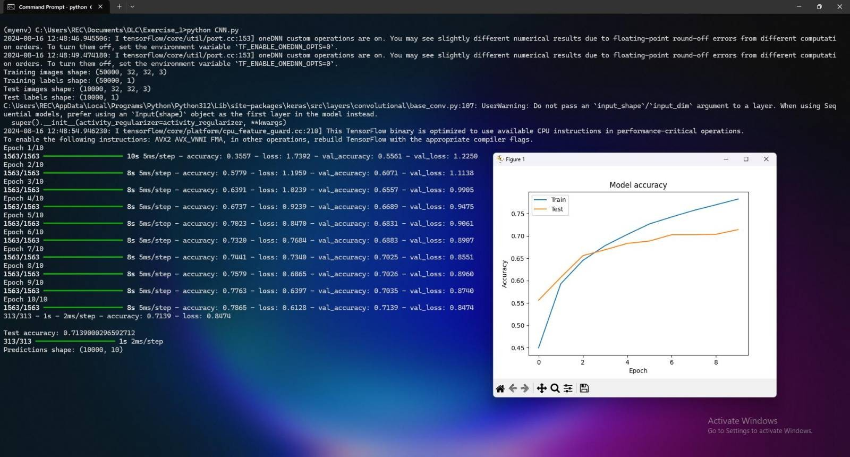

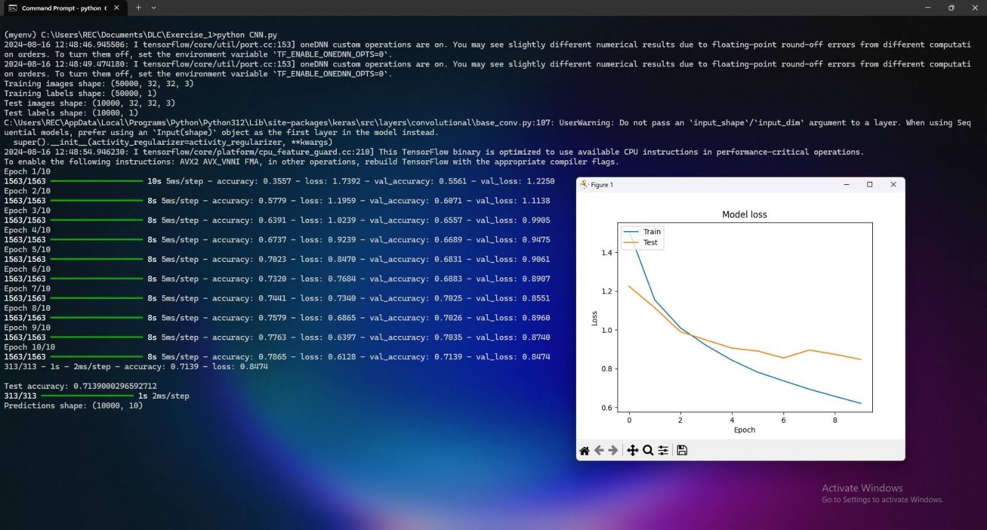

Result:

Thus, to build a convolutional neural network using keras has been completed successfully.